Chapter 6 Data Link Layer

6.0 Introduction to Data Link Layer
6.1 Services to the Network Layer
6.2 Framing
6.3 Flow Control
6.4 Error Detection and Control

6.0 Introduction to Data Link Layer

The Data Link layer is located between physical and network layers. It provides services to the Network layer and it receives services from the physical layer.
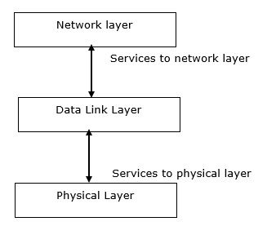
Objective
Achieving reliable communication between two adjacent machines
Design Issues
- Framing: data are sent in blocks called frames, the beginning and end of each frame must be recognized by the receiver.
- Error control: bit errors introduced by the transmission system should be detected and/or corrected.
- Flow control: the sending station must not send frames at a rate faster than the receiving station can absorb them.
- Addressing: on a multipoint line, such as a LAN, the identity of the two stations involved in a transmission must be specified.
- Access Control: When multiple devices share the same communication channel there is a high probability of collision, so it’s the responsibility of DLL to check which device has control over the channel and CSMA/CD and CSMA/CA can be used to avoid collisions and loss of frames in the channel.

6.1 Addressing
The data link layer encapsulates the source and destination’s MAC address/ physical address in the header of each frame to ensure node-to-node delivery. MAC address is the unique hardware address that is assigned to the device while manufacturing.

Media Access Control (MAC) Address
MAC Addresses are unique 48-bits hardware number of a computer, which is embedded into a network card (known as a Network Interface Card) during the time of manufacturing. MAC Address is also known as the Physical Address of a network device. In IEEE 802 standard, Data Link Layer is divided into two sublayers
- Logical Link Control(LLC) Sublayer
- Media Access Control(MAC) Sublayer
MAC address is used by the Media Access Control (MAC) sublayer of the Data-Link Layer. MAC Address is worldwide unique since millions of network devices exist and we need to uniquely identify each.

6.2 Framing
The data link layer packs these bits into frames. Data-link layer takes the packets from the Network Layer and encapsulates them into frames. If the frame size becomes too large, then the packet may be divided into small sized frames. Smaller sized frames makes flow control and error control more efficient.
Then, it sends each frame bit-by-bit on the hardware. At receiver’s end, data link layer picks up signals from hardware and assembles them into frames.
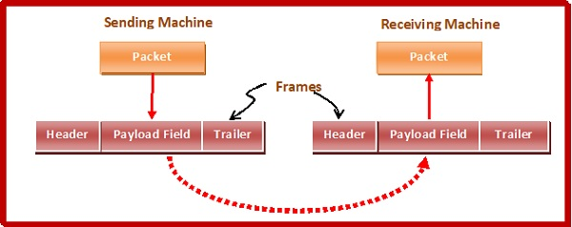

Parts of a Frame
A frame has the following parts
- Frame Header − It contains the source and the destination addresses of the frame.
- Payload field − It contains the message to be delivered.
- Trailer − It contains the error detection and error correction bits.
- Flag − It marks the beginning and end of the frame.

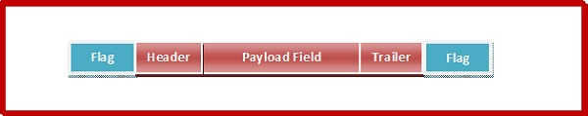

Types of Framing
Framing can be of two types, fixed sized framing and variable sized framing.
Fixed-sized Framing
Here the size of the frame is fixed and so the frame length acts as delimiter of the frame. Consequently, it does not require additional boundary bits to identify the start and end of the frame.
Variable – Sized Framing
Here, the size of each frame to be transmitted may be different. So additional mechanisms are kept to mark the end of one frame and the beginning of the next frame.
Two ways to define frame delimiters in variable sized framing are −
- Length Field − Here, a length field is used that determines the size of the frame. It is used in Ethernet (IEEE 802.3).
- End Delimiter − Here, a pattern is used as a delimiter to determine the size of frame. It is used in Token Rings. If the pattern occurs in the message, then two approaches are used to avoid the situation −
  - Byte – Stuffing − A byte is stuffed in the message to differentiate from the delimiter. This is also called character-oriented framing.
  - Bit – Stuffing − A pattern of bits of arbitrary length is stuffed in the message to differentiate from the delimiter. This is also called bit – oriented framing.

6.3 Flow Control
Flow control is a technique that allows two stations working at different speeds to communicate with each other. It is a set of measures taken to regulate the amount of data that a sender sends so that a fast sender does not overwhelm a slow receiver. In data link layer, flow control restricts the number of frames the sender can send before it waits for an acknowledgment from the receiver.
Approaches of Flow Control
Flow control can be broadly classified into two categories
- Feedback based Flow Control In these protocols, the sender sends frames after it has received acknowledgments from the user. This is used in the data link layer.
- Rate based Flow Control These protocols have built in mechanisms to restrict the rate of transmission of data without requiring acknowledgment from the receiver. This is used in the network layer and the transport layer.

Flow Control Techniques in Data Link Layer
Data link layer uses feedback based flow control mechanisms. There are two main techniques −

Stop and Wait
This protocol involves the following transitions
- The sender sends a frame and waits for acknowledgment.
- Once the receiver receives the frame, it sends an acknowledgment frame back to the sender.
- On receiving the acknowledgment frame, the sender understands that the receiver is ready to accept the next frame. So it sender the next frame in queue.

Sliding Window
This protocol improves the efficiency of stop and wait protocol by allowing multiple frames to be transmitted before receiving an acknowledgment.
The working principle of this protocol can be described as follows
- Both the sender and the receiver has finite sized buffers called windows. The sender and the receiver agrees upon the number of frames to be sent based upon the buffer size.
- The sender sends multiple frames in a sequence, without waiting for acknowledgment. When its sending window is filled, it waits for acknowledgment. On receiving acknowledgment, it advances the window and transmits the next frames, according to the number of acknowledgments received.

6.4 Error Detection and Control
Error control in data link layer is the process of detecting and correcting data frames that have been corrupted or lost during transmission.
In case of lost or corrupted frames, the receiver does not receive the correct data-frame and sender is ignorant about the loss. Data link layer follows a technique to detect transit errors and take necessary actions, which is retransmission of frames whenever error is detected or frame is lost. The process is called Automatic Repeat Request (ARQ).
Phases in Error Control
The error control mechanism in data link layer involves the following phases
- Detection of Error − Transmission error, if any, is detected by either the sender or the receiver.
- Acknowledgment − acknowledgment may be positive or negative.
  - Positive ACK − on receiving a correct frame, the receiver sends a positive acknowledge.
  - Negative ACK − on receiving a damaged frame or a duplicate frame, the receiver sends a negative acknowledgment back to the sender.
- Retransmission − the sender maintains a clock and sets a timeout period. If an acknowledgment of a data-frame previously transmitted does not arrive before the timeout, or a negative acknowledgment is received, the sender retransmits the frame.

Types of Errors
There may be three types of errors:
- Single bit error
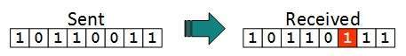
In a frame, there is only one bit, anywhere though, which is corrupt.
- Multiple bits error
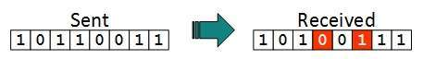
Frame is received with more than one bits in corrupted state.
- Burst error
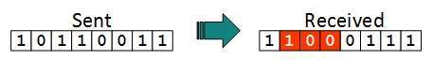
Frame contains more than1 consecutive bits corrupted.

Data-link layer uses some error control mechanism to ensure that frames (data bit streams) are transmitted with certain level of accuracy. Error control mechanism may involve the following
- Error detection
- Error correction
- Error control

Error Detection
Errors in the received frames are detected by means of Parity Check and Cyclic Redundancy Check (CRC). In both cases, few extra bits are sent along with actual data to confirm that bits received at other end are same as they were sent. If the counter-check at receiver’ end fails, the bits are considered corrupted.

Parity Check
One extra bit is sent along with the original bits to make number of 1s either even in case of even parity, or odd in case of odd parity.
The sender while creating a frame counts the number of 1s in it. For example, if even parity is used and number of 1s is even then one bit with value 0 is added. This way number of 1s remains even. If the number of 1s is odd, to make it even a bit with value 1 is added.
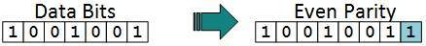
The receiver simply counts the number of 1s in a frame. If the count of 1s is even and even parity is used, the frame is considered to be not-corrupted and is accepted. If the count of 1s is odd and odd parity is used, the frame is still not corrupted.
If a single bit flips in transit, the receiver can detect it by counting the number of 1s. But when more than one bits are erroneous, then it is very hard for the receiver to detect the error.

Cyclic Redundancy Check (CRC)
CRC is a different approach to detect if the received frame contains valid data. This technique involves binary division of the data bits being sent. The divisor is generated using polynomials. The sender performs a division operation on the bits being sent and calculates the remainder. Before sending the actual bits, the sender adds the remainder at the end of the actual bits. Actual data bits plus the remainder is called a code word. The sender transmits data bits as code words.
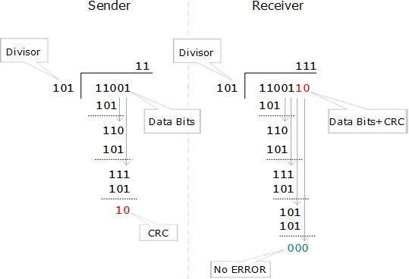
At the other end, the receiver performs division operation on code words using the same CRC divisor. If the remainder contains all zeros the data bits are accepted, otherwise it is considered as there some data corruption occurred in transit.
- Error Correction
In the digital world, error correction can be done in two ways:
- Backward Error Correction When the receiver detects an error in the data received, it requests back the sender to retransmit the data unit.
- Forward Error Correction When the receiver detects some error in the data received, it executes error-correcting code, which helps it to auto-recover and to correct some kinds of errors.
The first one, Backward Error Correction, is simple and can only be efficiently used where retransmitting is not expensive. For example, fiber optics. But in case of wireless transmission retransmitting may cost too much. In the latter case, Forward Error Correction is used.
To correct the error in data frame, the receiver must know exactly which bit in the frame is corrupted. To locate the bit in error, redundant bits are used as parity bits for error detection. For example, we take ASCII words (7 bits data), then there could be 8 kind of information we need: first seven bits to tell us which bit is error and one more bit to tell that there is no error.
- Error Control
There are three main techniques for error control
- Stop and Wait ARQ
This protocol involves the following transitions
  - A timeout counter is maintained by the sender, which is started when a frame is sent.
  - If the sender receives acknowledgment of the sent frame within time, the sender is confirmed about successful delivery of the frame. It then transmits the next frame in queue.
  - If the sender does not receive the acknowledgment within time, the sender assumes that either the frame or its acknowledgment is lost in transit. It then retransmits the frame.
  - If the sender receives a negative acknowledgment, the sender retransmits the frame.
- Go-Back-N ARQ
The working principle of this protocol is
  - The sender has buffers called sending window.
  - The sender sends multiple frames based upon the sending-window size, without receiving the acknowledgment of the previous ones.
  - The receiver receives frames one by one. It keeps track of incoming frame’s sequence number and sends the corresponding acknowledgment frames.
  - After the sender has sent all the frames in window, it checks up to what sequence number it has received positive acknowledgment.
  - If the sender has received positive acknowledgment for all the frames, it sends next set of frames.
  - If sender receives NACK or has not receive any ACK for a particular frame, it retransmits all the frames after which it does not receive any positive ACK.
- Selective Repeat ARQ
  - Both the sender and the receiver have buffers called sending window and receiving window respectively.
  - The sender sends multiple frames based upon the sending-window size, without receiving the acknowledgment of the previous ones.
  - The receiver also receives multiple frames within the receiving window size.
  - The receiver keeps track of incoming frame’s sequence numbers, buffers the frames in memory.
  - It sends ACK for all successfully received frames and sends NACK for only frames which are missing or damaged.
  - The sender in this case, sends only packet for which NACK is received.

